Online Exam
Step by Step Demonstration

Step-01.

Visit https://kukonlineexam.com/ and Click on New Registration button for new registration.
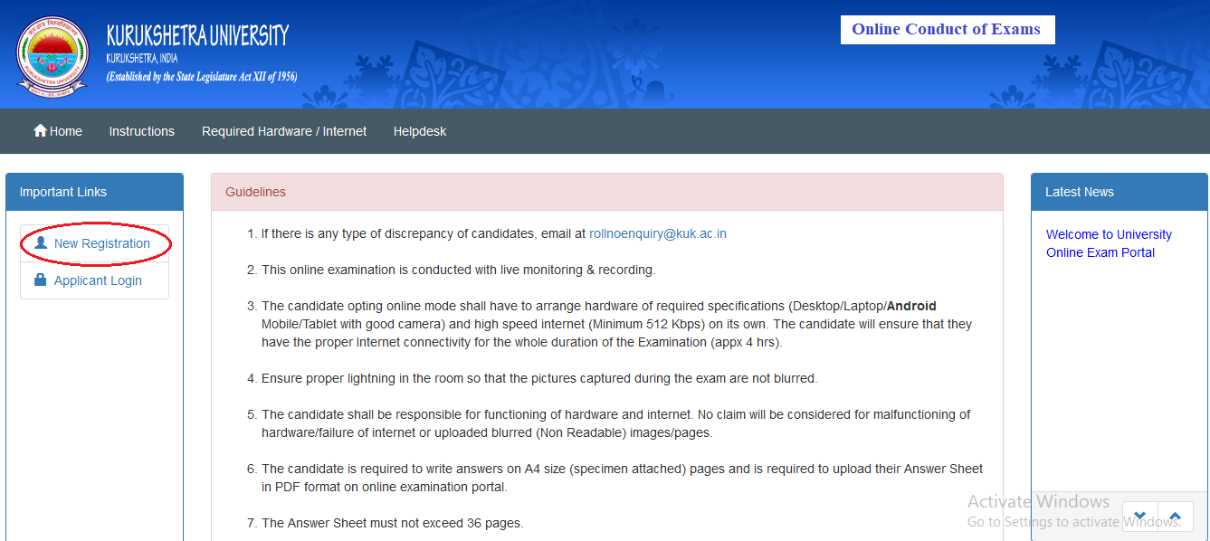

Step -02.

Select and fill Exam name, Roll No, Email id, Mobile, Captcha then Click on Register button . If you don’t have Roll No then click on Click here to know your Roll No. button.

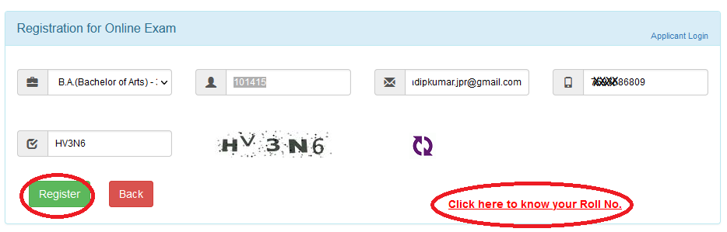

Step –03. For Roll no., Select Class, Enter Name & Click on Submit button.

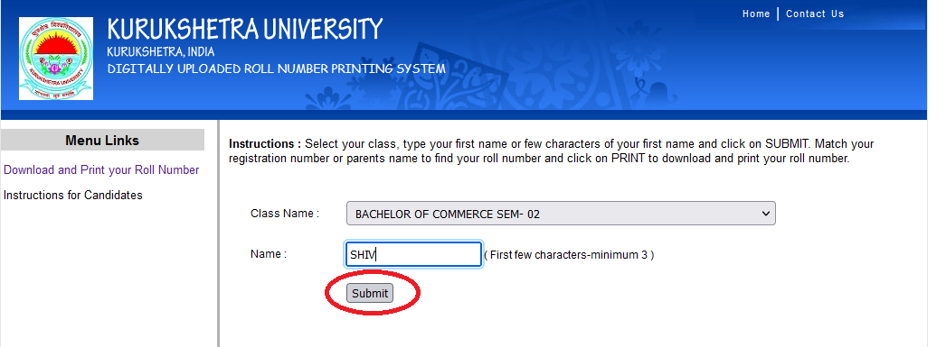

Step –04. After searching the Roll no. fill the relevant information and Click on Register button.

Step –05. Check your details, registered Subjects, Enter OTP (Received on your mobile No), Click on Continue to Complete Registration Form button. In case there is any disparity in your subjects, email the problem to the University at given email ID.
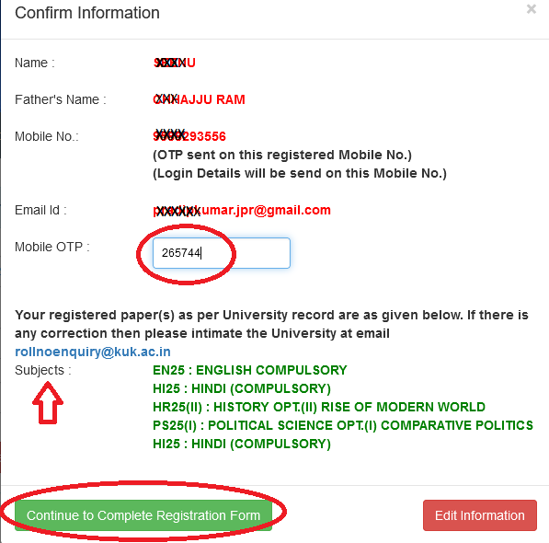

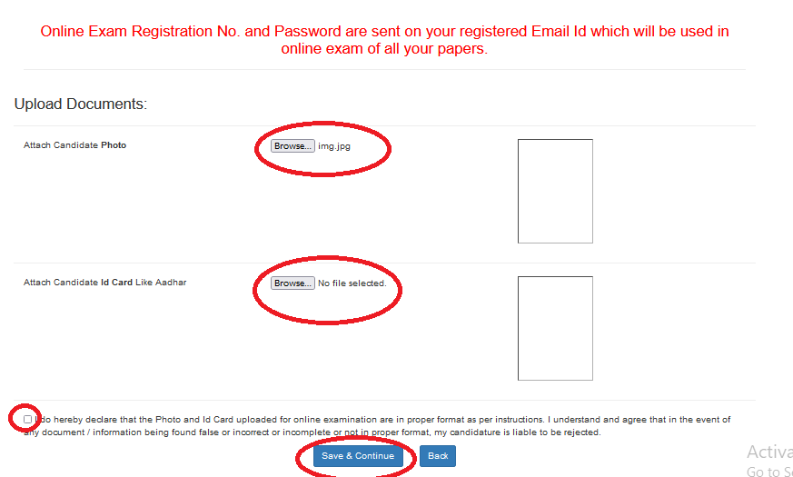
Step –06. Click on Browse button and upload your Photo and Aadhaar Card, Click in check box and click on Save and Continue button.

Step –07. Now take Mock test. Click on Capture Photo and upload Photo, Capture photo ID and upload photo ID, check in declaration & click on Start Exam for mock test.
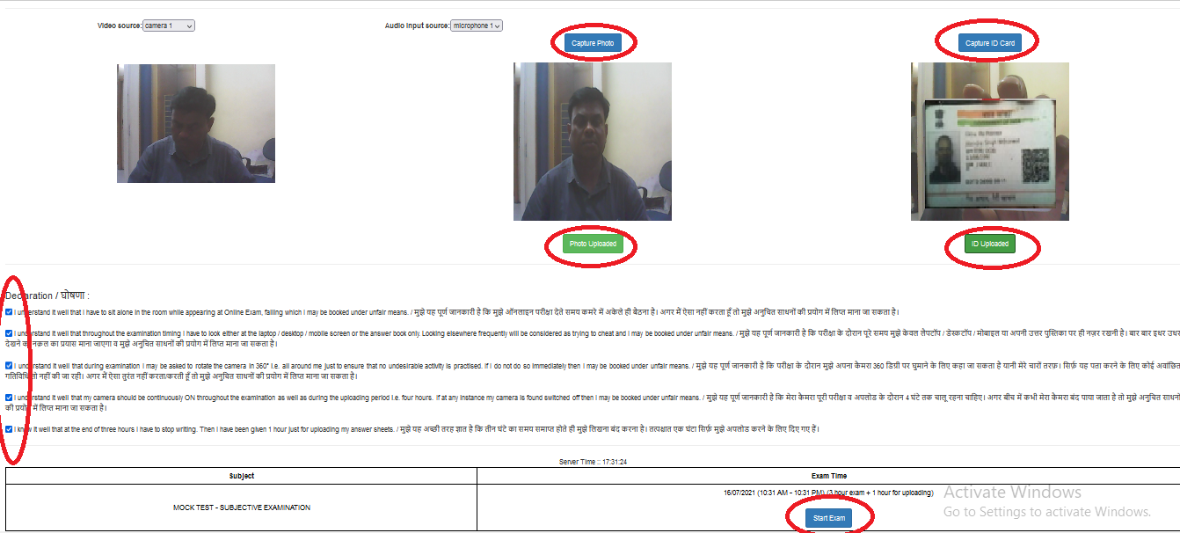

Step –08. You can see the question paper on the right side of the screen. After completing the exam, make a pdf file of all the sheets on which you have written the answers. Click browse and select your pdf file and upload the pdf file. You can click view file button to view the uploaded file.
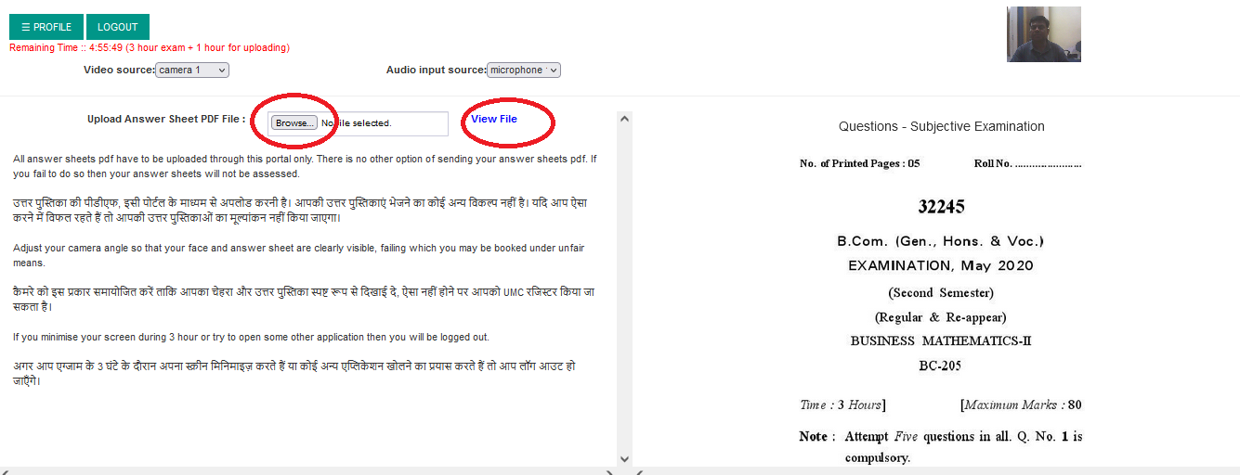

Step –09. For the actual exam:
Click on Application Login button and use login id and Password which you had received on your email ID.
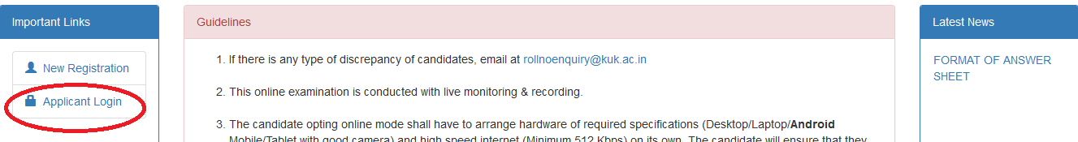

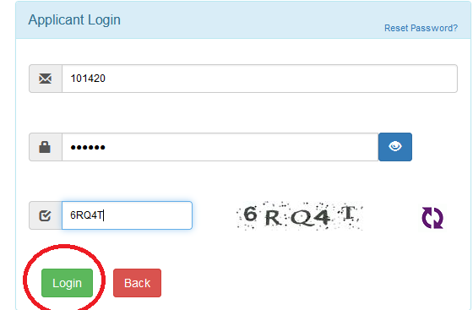

Step –10. You will see all registered subjects with scheduled date and time of examination. Click on Start button for the scheduled Online Examination. Rest process is same as demonstrated before.
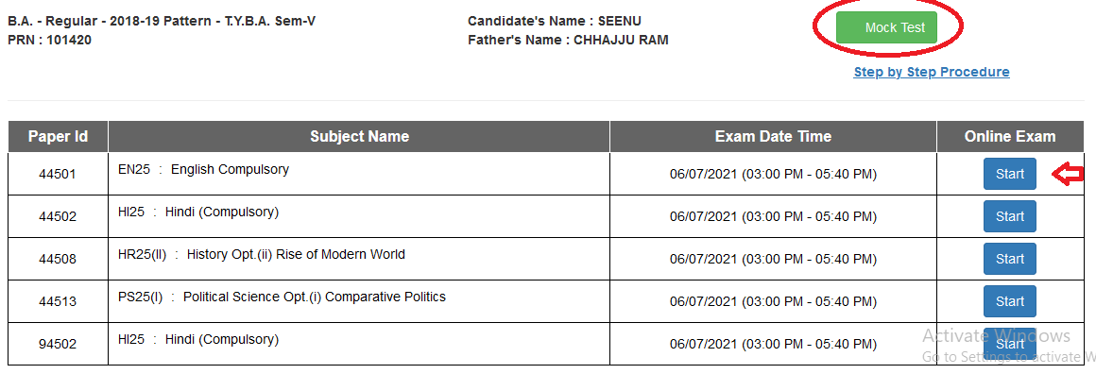

END

